**Aim:** Create a Virtual Machine with 1 CPU, 2GB RAM and 15GB storage disk using a Type 2 Virtualization Software.

**Step 1:** Create a virtual machine without OS. Create with disk size of 15GB.

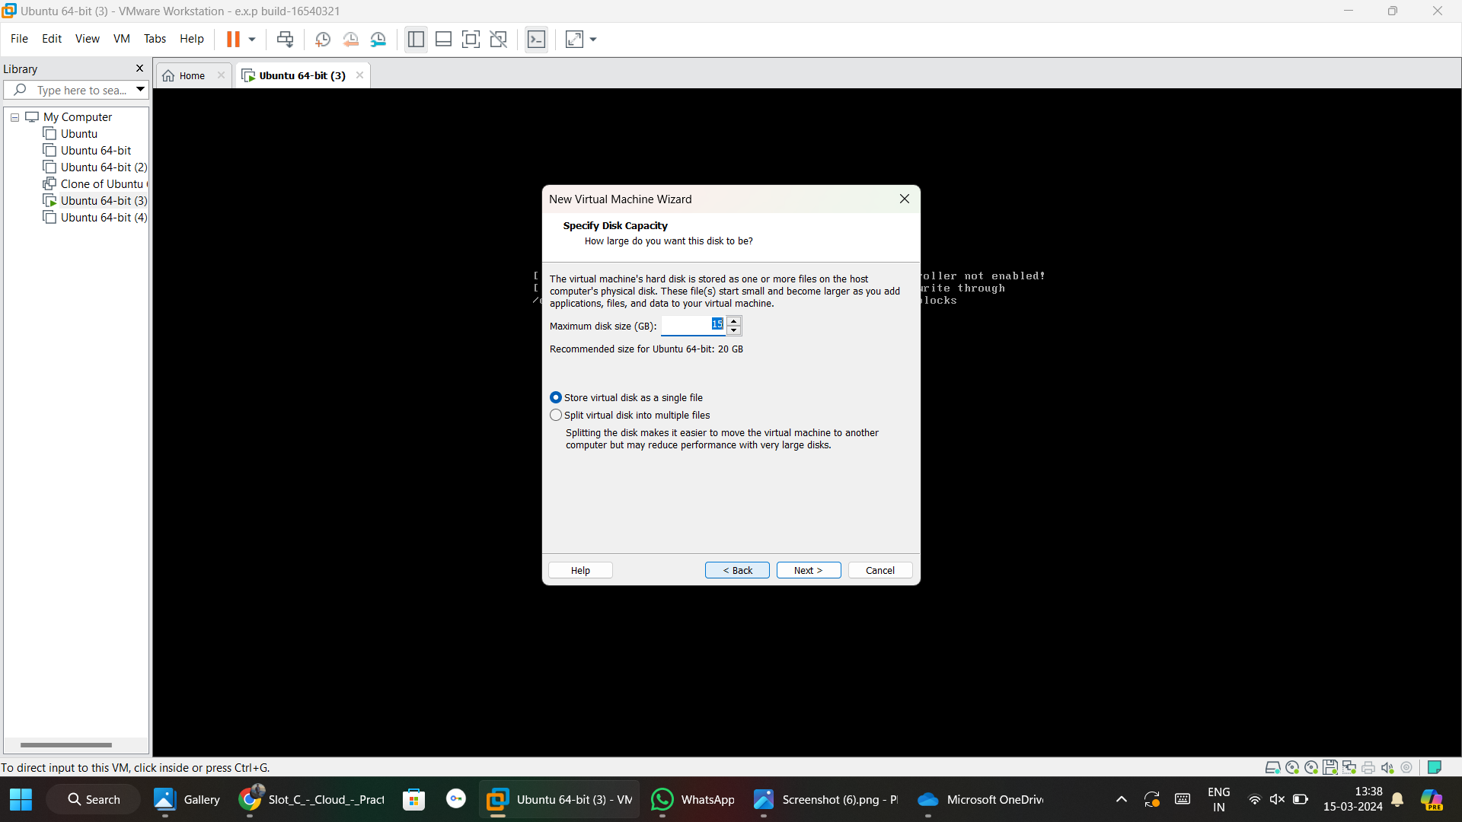

**Step 2:** After creating OS, we have to change specifications.

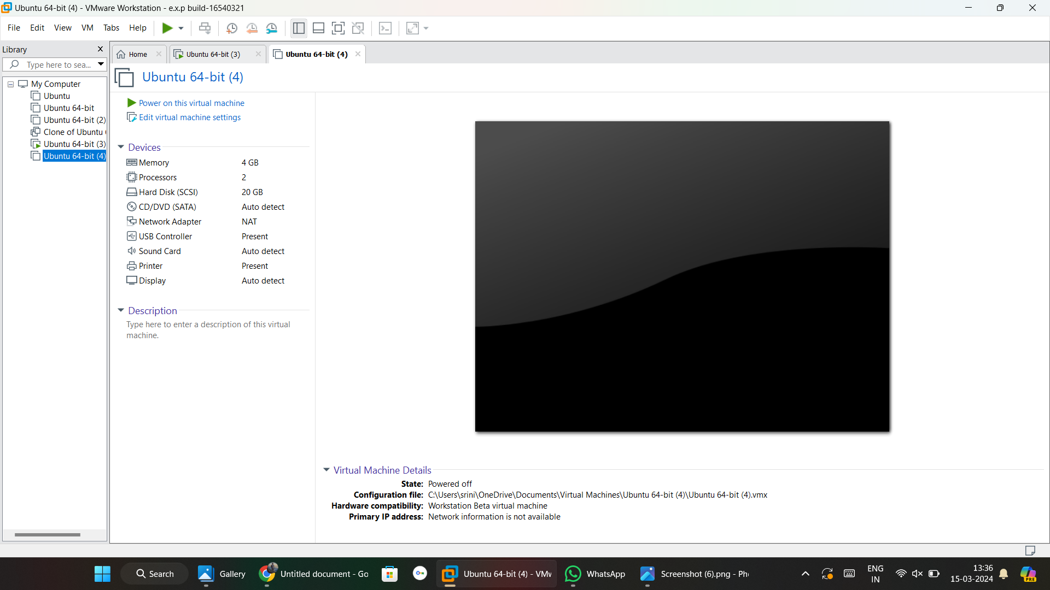

**Step 3:** Click on edit virtual machine setting and change configuration

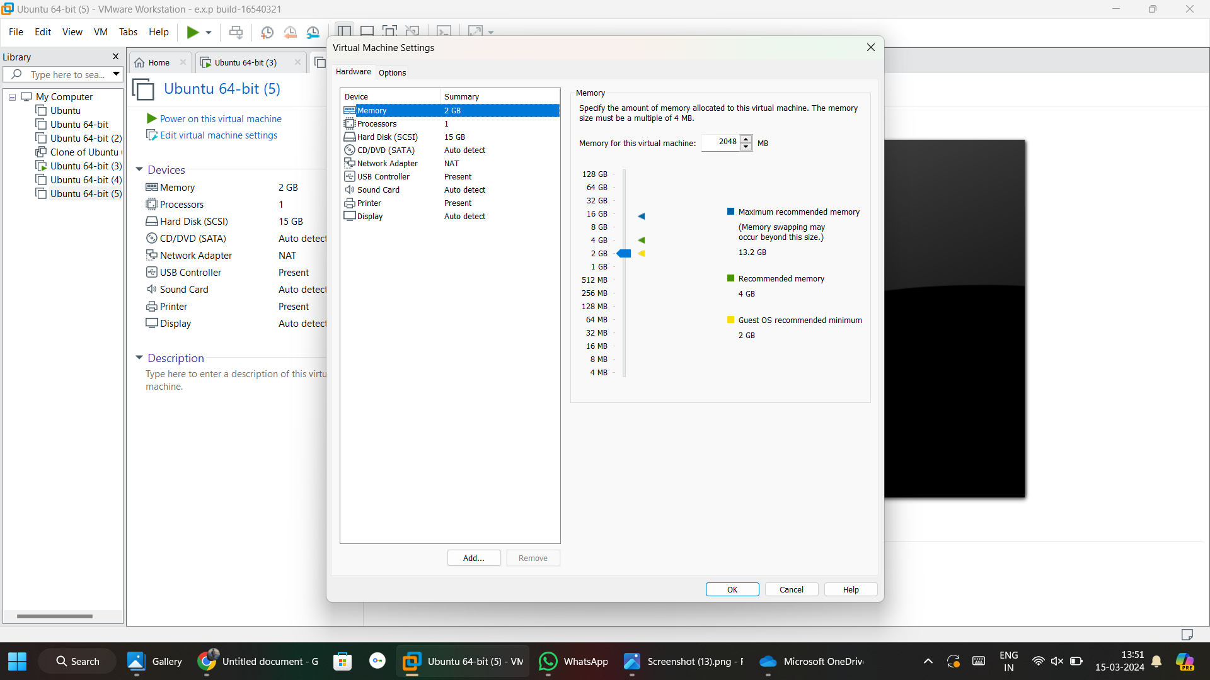

**Step 4:** Finally virtual machine created with given configuration.

